ASSISTED PROJECT EMP ID:2587303

NAME:R.HIMABINDU

11.Demonstrate how Sikuli is used for UI testing in Selenium.

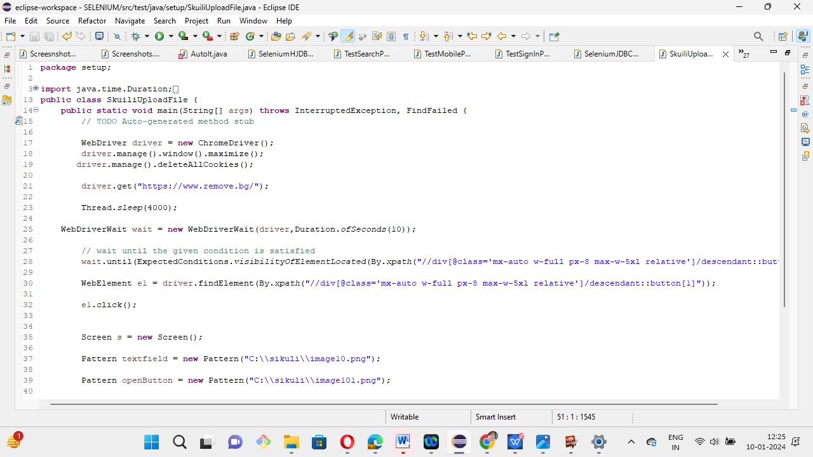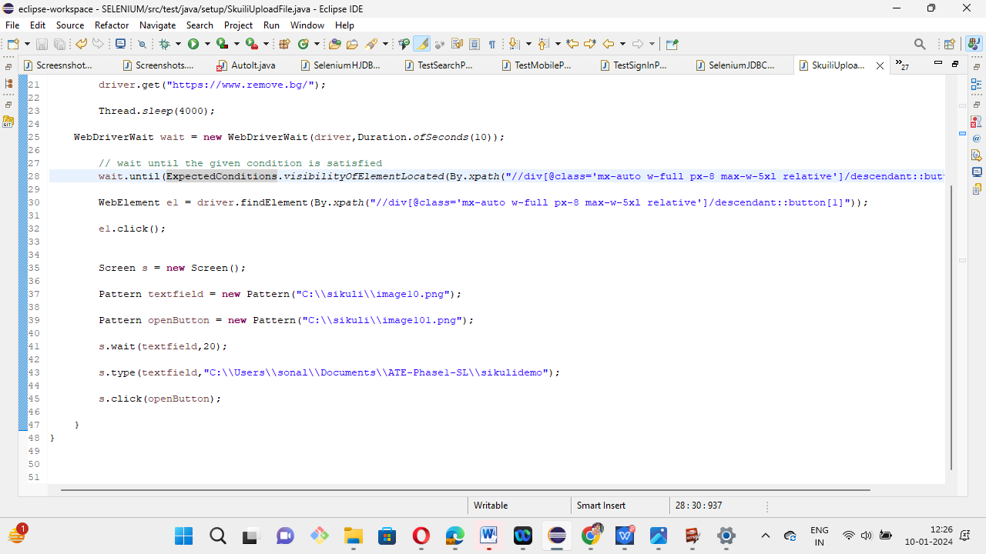

12. Demonstrate the usage of JDBC in Selenium. 